Profile
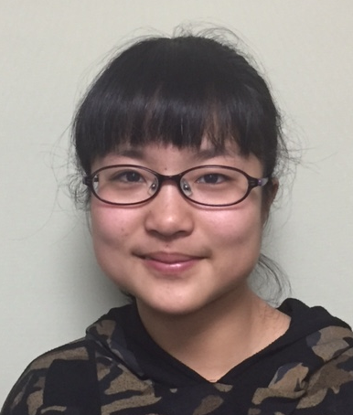
Name: Noji Ayane
family name given name
Nationality: Japan
Birth date: 29/7/2002 (day/month/year)
Age: 14 Sex: Female
School (year): 8th grade in Ouchi Junior High School

Family (name, age and occupation)
Father: Masanori, 40, architect
Mother: Mayumi, 45, nurse
Siblings: None
Pet: Chataro, 8 years old, Chiwawa

Allergy: None Religion: Buddhist

Message

Dear Family,
Thank you very much for becoming my host family. My name is Noji Ayane. Please call me Ayane. I’m a member of the softball club in my school. My hobby is listening to music. I like animals. I have a dog named Chataro. He is my good friend. Do you have any pets? I like cooking, too. If I can, I want to learn American cooking. And I want to cook some Japanese dish for you.
I am very excited to go to the United States this spring. I’m looking forward to seeing you.
Sincerely,
野地彩音

